ANCIENT EGYPTIAN SOCIETY
THE ROYAL FAMILY
The King of Egypt held absolute power in his country. He was a ruler, a general and the chief priest of all the gods. He was also himself, divine.
The Pharaoh was thought to be a god – the descendent of the sun god. And the spirit of the hawk god Horus was held to enter into him as he sat on the throne with his royal regalia – the crown, the crook and the flail. When he died, he became one with Osiris, the God of the Dead.
Below the pharaoh, the highest official in the land was the vizier, chief executive of all Egypt. The vizier administered the law as impartially as possible and was overlord of the Treasury.
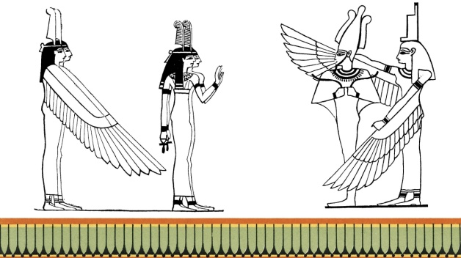

THE NOBLES:
Lesser officials and nobles received smaller grants through either the Pharaoh or through the wealthier nobles and officials. Often these grants were meant to provide a salary for the officials. In order to retain this salary it is not surprising that many official positions became hereditary, carried on from father to son.
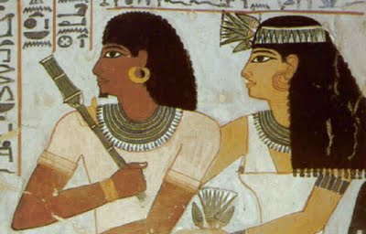
http://egyptiananachronism.blogspot.com.au/2011/09/wonderfull-things-from-valley-of-nobles.html
Painting from the tomb of Sennefer, Mayor of the City of Thebes and Overseer of the Granaries, Fields, Gardens, and Cattle of Amun during the reign of Amenhotep II

THE PRIESTS:
One of the important duties of the priests was the embalming ritual. Priests had many other duties to perform. They were responsible for organising the local festivals of the Gods, many of which were over a week long, such as the harvest and the New Year festivals. Priests of lower rank included scholars, astrologers, scribes, singers and musicians.
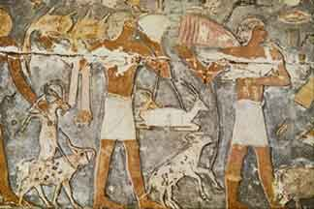
http://www.google.com.au/imgres?q=ancient+egyptian+priest&um=1&sa=N&biw=1024&bih=585&hl=en&tbm=isch&tbnid=4m4LkwG53_c2sM:&imgrefurl=http://www.historylink101.com/n/egypt_1/religion_role_of_priest.htm&docid=GeHqE4RTJM5SbM&imgurl=http://www.historylink101.com/n/preist_bring_offerings.jpg&w=324&h=216&ei=TMHTUaPML47nkgW4_IGoBg&zoom=1&iact=hc&vpx=365&vpy=5&dur=1781&hovh=172&hovw=259&tx=146&ty=85&page=1&tbnh=145&tbnw=223&start=0&ndsp=21&ved=1t:429,r:2,s:0,i:88

THE CRAFTSMEN:
Besides the peasants and the nobles, Egypt had a small but important middle class. Many of its members were the artists and craftsmen who made all the things that made life in Egypt comfortable. Some were craftsmen who made things for the local market. Others were employed in the workshops of rich patrons, attached to a temple, palace or nobleman’s estate.
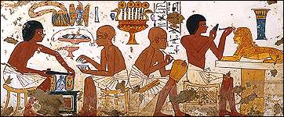
http://www.ancientegypt.co.uk/trade/home.html

THE FARMERS:
Most peasants were serfs or bondmen, bound to serve on the lands of their masters. At the same time the peasants could own small plots of land on which they cultivated crops after the work of their masters was completed. They laboured on the fields from dawn til nightfall. This often made the life of the peasant very difficult.
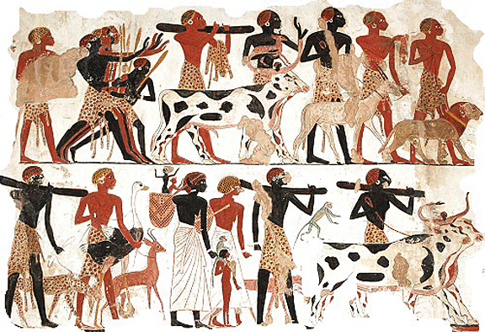
http://www.google.com.au/imgres?q=ancient+egyptian+farmers&um=1&hl=en&biw=1024&bih=585&tbm=isch&tbnid=VwTWLoh2pnuuJM:&imgrefurl=http://www.egyptianagriculture.com/horticulture.html&docid=nIpOg5RFbFsrFM&imgurl=http://www.egyptianagriculture.com/images/egyptian_farming.gif&w=576&h=394&ei=O8LTUa2PEYShkgW5ioCYBw&zoom=1&iact=hc&vpx=146&vpy=234&dur=31&hovh=186&hovw=272&tx=90&ty=105&page=1&tbnh=140&tbnw=205&start=0&ndsp=15&ved=1t:429,r:6,s:0,i:102

In the early days of the Ancient Egyptian Kingdom, it is likely that there were only three classes of people. The King (Pharaoh), his more important servants and officials together with the great nobles formed on class. The lesser nobility and other officials formed a middle class while the bulk of Ancient Egypt’s people – peasants, labourers and craftsmen formed the lower class. Chose one of the Ancient Egyptian peoples and write notes about their lifestyle under the following headings:
HOMES | FOOD
CLOTHING | JEWELLERY
COSMETICS | HAIRSTYLE
LEISURE | RELIGION

